OSINT Challenge Report Template

OSINT Challenge: Investigating the Unknown
Intern Name: Prince Ndutimi
Intern Email: ndutimiprince15@gmail.com
Date Submitted: 19/04/2025

1. Executive Summary
Provide a brief overview of your investigation, the tools you used, and the key findings.
- Objective: To carry out an OSINT research on a coffee shop
- Key Findings:
The research revealed the street, town and city the coffee shop is located in
The research revealed Perth and Ross to be the actual city the coffee shop is located and not Blairgowrie. Blairgowrie is the town where the coffee shop is located.
The research revealed Debbie and David Cochrane to be the owners of the coffee shop
The research revealed that on the 19th of April 2025, the windows of the coffee shop was damaged. The cause of damage is yet unknown.

2. Investigation Details

2.1 Tools and Techniques Used
- Google images
- Facebook
- Tripadvisor

2.2 Process
I started by using Google images to help with the name of the coffee shop and different suggestions came up, their Facebook account likewise. I then used their Facebook account to get their phone number and email address. Also used the information given by the Facebook account to further make my findings on google, which brought me to the owners name I saw on barba.org.uk

3. Findings
Question | Your Answer | Evidence/Links
1. Which city is this coffee shop located in? | Perth And Kinross | https://www.barba.org.uk/blairgowrie-and-rattray-businesses/the-wee-coffee-shop
2. Which street is this coffee shop located in? | 1 Allan Street | https://ratings.food.gov.uk/business/1201198
3. What is their phone number? | +44 7878 839128 | https://web.facebook.com/weecoffeeshop/?_rdc=1&_rdr#
4. What is their email address? | theweecoffeeshop@aol.com | https://web.facebook.com/weecoffeeshop/?_rdc=1&_rdr#
5. What is the surname of the owners? | Cochrane | https://www.barba.org.uk/blairgowrie-and-rattray-businesses/the-wee-coffee-shop

4. Challenges Faced
Blairgowrie isn’t the city the coffee shop is located as widely claimed, rather it’s a town located in the city of Perth and Ross

5. Lessons Learned
Attention to details is key. For every search, there’s an information waiting to be unraveled.

6. Recommendations (Optional)
- Automate Routine OSINT Queries
- Document Evidence and Sources Clearly
7. Supporting Documents
Attach any screenshots or files to support your findings.
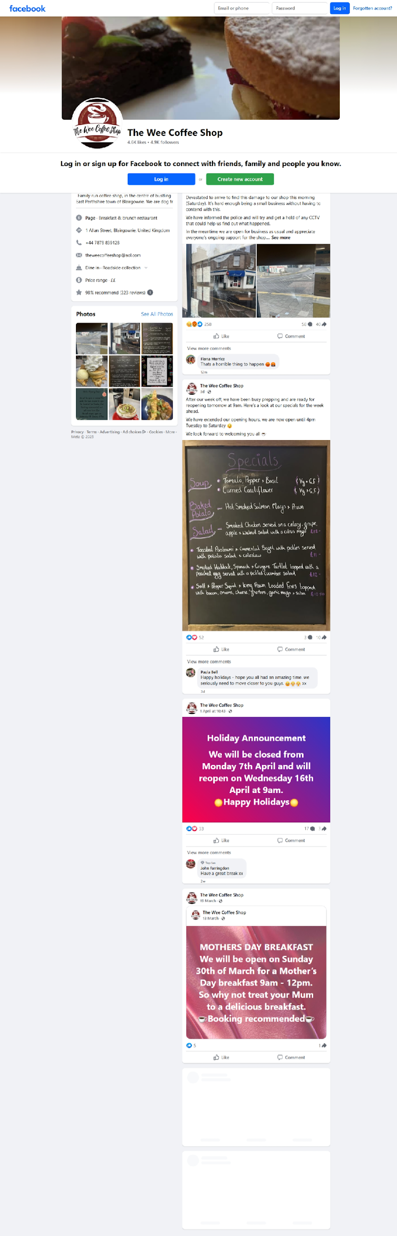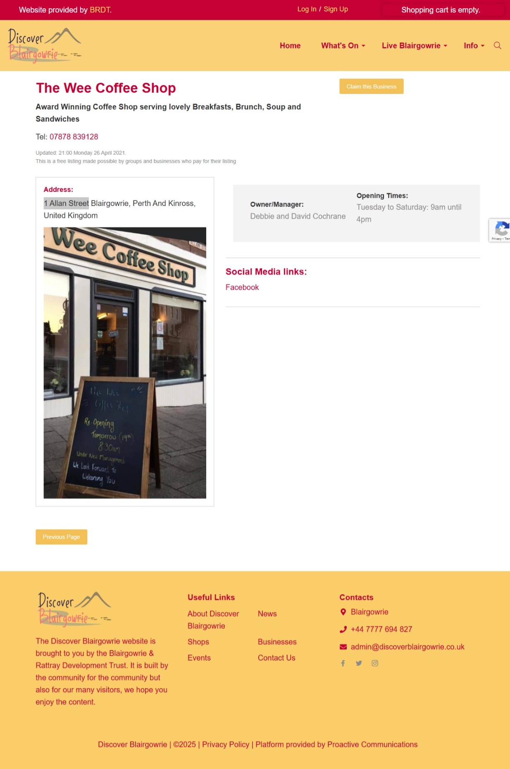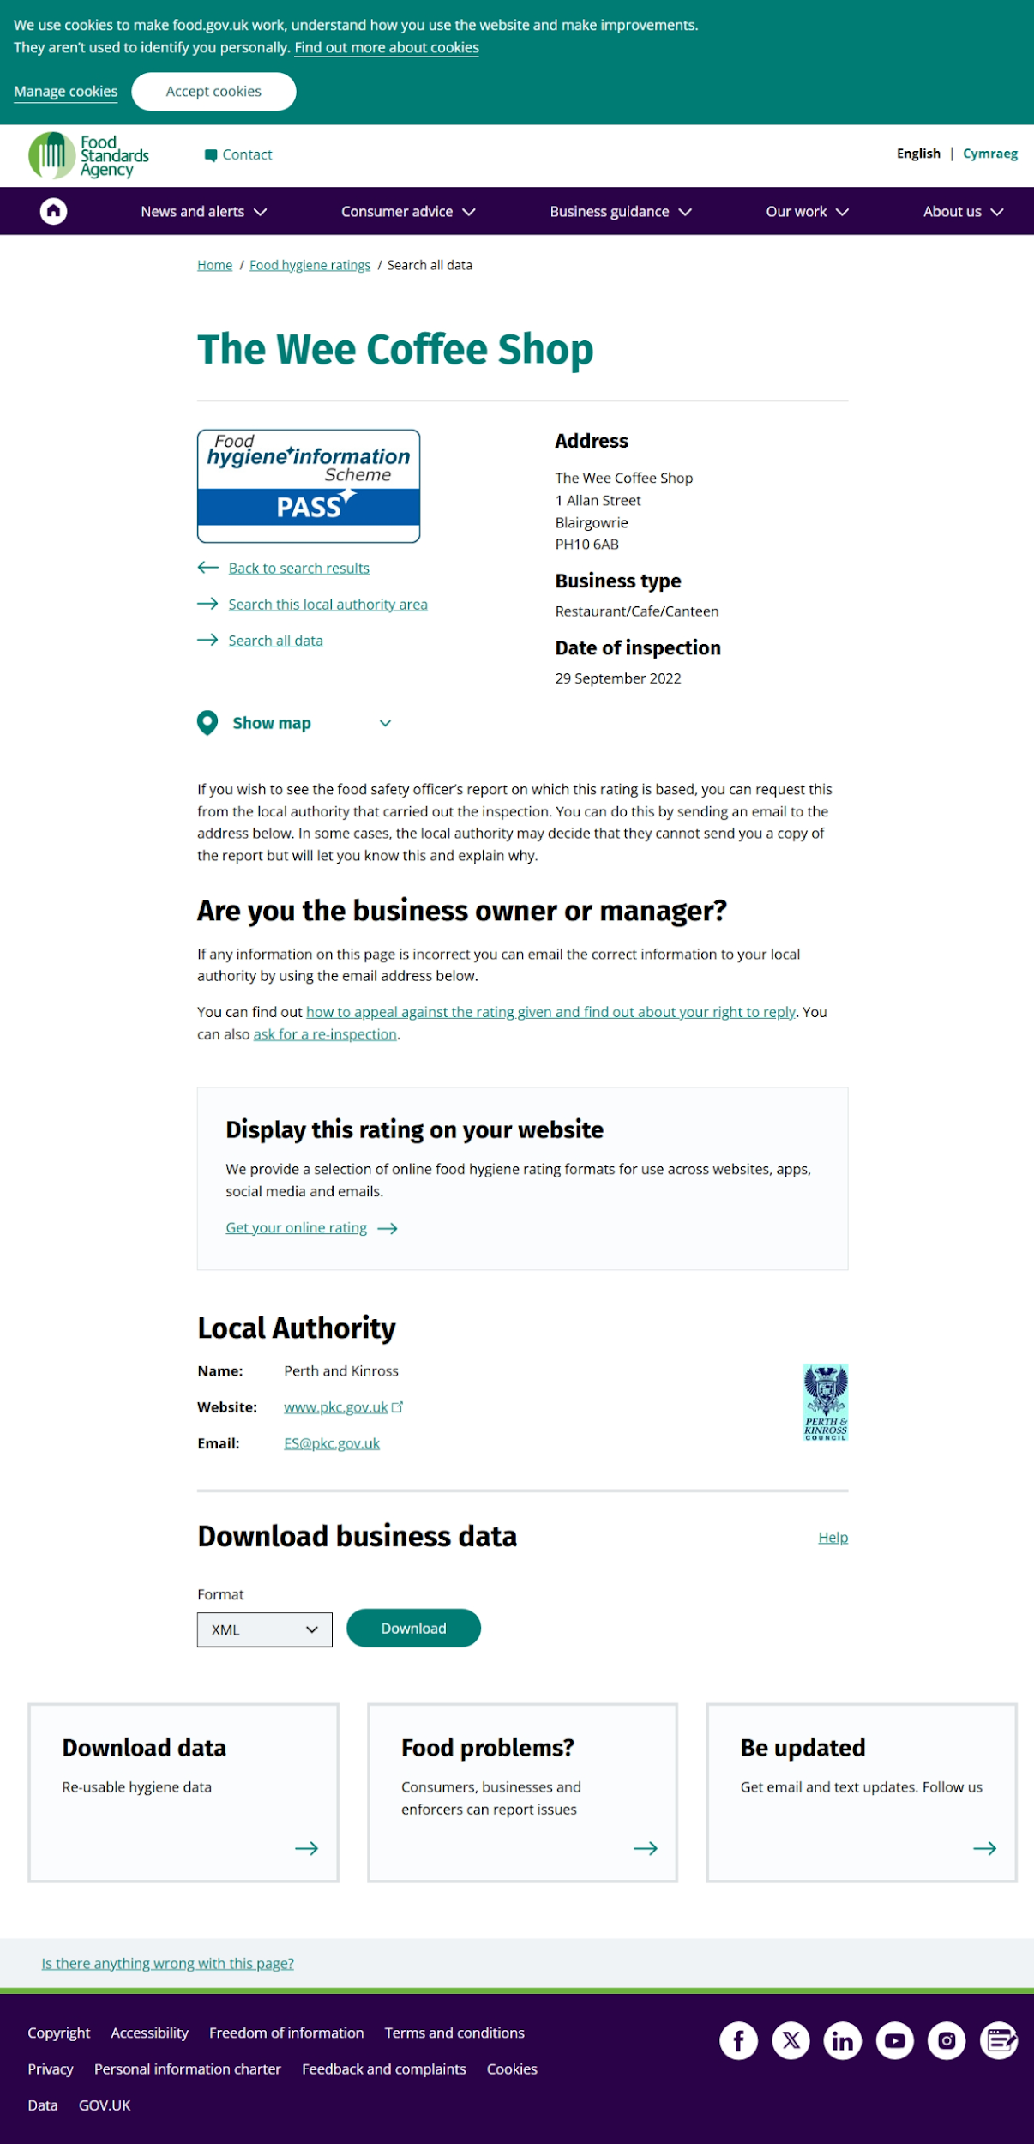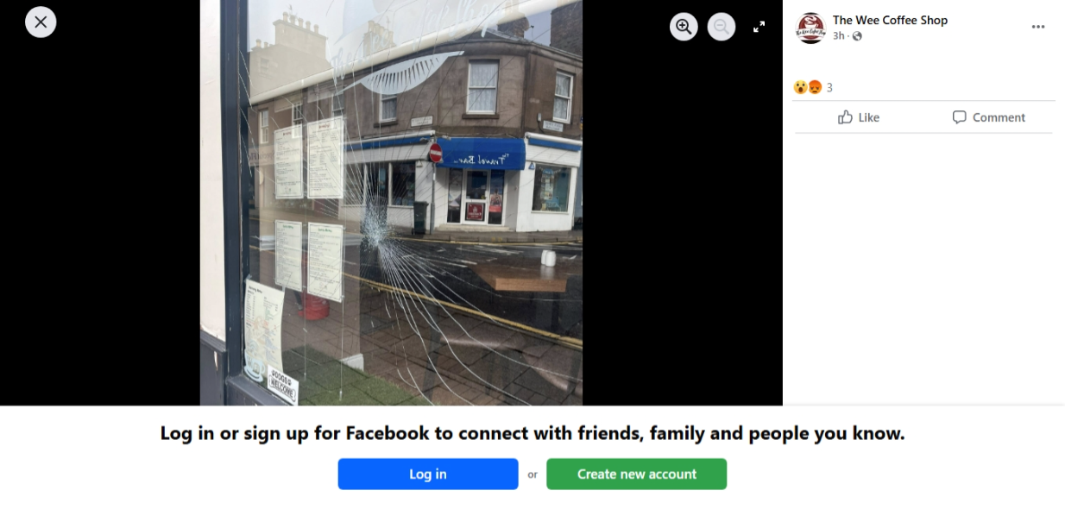
Example:
- Reverse Image Search Screenshot
- Google Dorking Query and Results Screenshot
I confirm that this report is my original work and accurately reflects my investigation for this OSINT challenge.
Signature: Prince Ndutimi

